Edge-Optimized Dual-Model Architecture for Real-Time Passenger Safety and Fall Detection

Devesh Nath Jha
Dept. of Computer Science & Engg. (AI & ML)
Dr. B. C. Roy Engineering College
Durgapur, India
deveshjnv2002@gmail.com

Vishwajit Kumar Kanth
Dept. of Computer Science & Engg. (AI & ML)
Dr. B. C. Roy Engineering College
Durgapur, India
vishwajitkumarkanth@gmail.com

Kumar Saurav
Dept. of Computer Science & Engg. (AI & ML)
Dr. B. C. Roy Engineering College
Durgapur, India
saurav.ambasta777@gmail.com

Raja Dey
Dept. of Computer Science & Engg. (AI & ML)
Dr. B. C. Roy Engineering College
Durgapur, India
rajadeycse@gmail.com

Abstract: Passenger safety within vehicles is a critical concern, necessitating real-time systems capable of identifying both sudden medical emergencies (such as passenger falls or collapses) and high-impact vehicular collisions. Traditional cloud-based detection systems suffer from latency and require persistent internet connectivity, making them unsuitable for split-second emergency responses. This paper proposes a production-ready Edge AI pipeline featuring a dual-model architecture designed to detect human falls and vehicle crashes in real-time. By utilizing a 6-axis Inertial Measurement Unit (IMU), the system streams accelerometer and gyroscope data at 50 Hz from a smartphone to a FastAPI WebSocket server over a local Wi-Fi/IP network. We evaluate multiple deep learning architectures and identify a lightweight 1-Dimensional Convolutional Neural Network (1D-CNN) as the optimal solution. The model is dynamically quantized using TensorFlow Lite (TFLite), achieving an 89% reduction in size (to ~15 KB) while maintaining a high accuracy of 96.65%. Furthermore, the system implements sensor fusion by integrating live GPS coordinates. In the event of a critical incident, such as a high-speed crash followed by rapid deceleration, the system triggers an automated Twilio-based SOS alert containing the exact geographical coordinates. Our results demonstrate an ultra-low inference latency of 2 to 6 ms, confirming the system's efficacy for instantaneous, life-saving deployment at the edge.
Keywords: Fall Detection, Vehicular Crash Detection, Edge AI, 1D-CNN, Sensor Fusion, TensorFlow Lite, FastAPI, Inertial Measurement Unit (IMU), Twilio SOS.

I. INTRODUCTION
The integration of Advanced Driver Assistance Systems (ADAS) has driven a paradigm shift in vehicular safety, focusing heavily on external collision avoidance, lane keep assist, and autonomous navigation. However, the interior safety of the passenger cabin remains a critical area requiring sophisticated real-time monitoring. Vulnerable demographics, such as the elderly or passengers with underlying medical conditions (such as epilepsy or cardiovascular distress), face significant risks of syncope, loss of balance, and subsequent falls while commuting in public or private transport. Simultaneously, in the event of a high-impact vehicular crash, the golden hour for medical response is frequently delayed due to the lack of automated, instantaneous distress signaling.
Historically, anomaly detection systems have relied on cloud computing architectures. In these frameworks, continuous sensor streams are transmitted over cellular networks to centralized servers for predictive inference. This methodology introduces several critical points of failure, including variable network latency, exorbitant bandwidth consumption for high-frequency telemetry, and an absolute reliance on consistent cellular coverage. In remote geographies or high-speed transit scenarios, network dropouts can render cloud-based emergency systems entirely ineffective.
Edge Artificial Intelligence (Edge AI) fundamentally resolves these bottlenecks by pushing the computational workload directly to the local device. By executing neural network inference locally, Edge AI guarantees deterministic, ultra-low latency responses independent of external network states.
This research proposes a comprehensive, highly optimized Edge AI framework designed to simultaneously monitor both individual passenger kinematic anomalies (falls) and systemic vehicular integrity (crashes). The principal contributions of this work are defined as follows:
- • Architecting a dual-model Edge AI pipeline utilizing localized 1-Dimensional Convolutional Neural Networks (1D-CNN) for binary classification of human falls and vehicular crashes.
- • Engineering a high-throughput FastAPI WebSocket server capable of processing continuous 50 Hz tri-axial accelerometer and gyroscope streams over a local Wi-Fi network without HTTP overhead.
- • Mathematical deployment of TensorFlow Lite (TFLite) dynamic range quantization to compress the 32-bit floating-point neural models into 8-bit integers, yielding an 89% reduction in parameter footprint (~15 KB).
- • Implementation of a deterministic Sensor Fusion protocol combining IMU confidence thresholds with live GPS tracking to automate a Twilio-based SOS subsystem during verified crash events.

II. RELATED WORK
The detection of human kinematic anomalies has been extensively researched, bifurcating primarily into computer vision methodologies and wearable sensor systems. Vision-based approaches leverage pose-estimation models (such as OpenPose or MediaPipe) utilizing RGB or depth cameras. While yielding high accuracy, they suffer from fundamental limitations in confined vehicular spaces, including physical occlusion, dynamic lighting variations, and profound privacy violations regarding continuous passenger surveillance _{[1]}.
Conversely, wearable sensor systems utilizing Inertial Measurement Units (IMUs) have demonstrated exceptional efficacy without compromising privacy _{[2], [3]}. Extensive literature demonstrates that threshold-based heuristic algorithms can detect falls via Sudden Magnitude Vector (SMV) spikes. However, these deterministic heuristics are plagued by false positives during Activities of Daily Living (ADLs) such as sitting abruptly or vehicle deceleration _{[4]}. Transitioning to Machine Learning, researchers have deployed Support Vector Machines (SVM), Random Forests, and Long Short-Term Memory (LSTM) networks to analyze the sequential temporal dependencies of IMU data _{[5]}. While LSTMs capture temporal nuances excellently, their recurrent nature makes them computationally expensive for continuous edge deployment.
In parallel, vehicular crash detection algorithms conventionally rely on hardware-based accelerometers triggering airbag deployment upon exceeding extreme G-force thresholds _{[6]}. Modern smartphone-based detection systems have attempted to utilize integrated GPS and accelerometers to dispatch emergency alerts, yet frequently fail to differentiate between a device dropping to the floorboard versus a genuine vehicular impact _{[7], [8]}.
This paper bridges these distinct domains by proposing a unified, hot-swappable edge application that not only classifies complex temporal patterns via 1D-CNNs but aggressively optimizes them for micro-controller level memory footprints via Post-Training Quantization.

III. PROPOSED SYSTEM ARCHITECTURE
The proposed system operates entirely as a localized, real-time computational node, bypassing external cloud inference APIs.

A. Telemetry Acquisition and Sliding Window Protocol
The hardware ecosystem utilizes a smartphone functioning as the primary sensor hub, transmitting data to the computational edge node (FastAPI server). The IMU captures 6-axis kinematics: Accelerometer (Ax, Ay, Az) and Gyroscope (Gx, Gy, Gz) at a continuous sampling frequency of fs = 50 Hz. Telemetry is serialized as a JSON payload and streamed over a persistent WebSocket connection. The sensor data is validated using a Pydantic schema enforcing realistic physical ranges (accelerometer X, Y, Z in [-20.0, 20.0] m/s² and gyroscope X, Y, Z in [-600.0, 600.0] °/s) to ensure data integrity before ingestion.
To transform the continuous data stream into discrete tensors suitable for neural inference, a sliding window technique is mathematically formulated. Let the continuous multivariate sensor stream be denoted as S = {s_1, s_2, ..., s_t}, where each s_t in R^6.
A window W_t of length N (where N = 128 samples, representing 2.56 seconds of physical time) is defined as:
W_{t} = [s_{t}, s_{t+1}, ..., s_{t+N-1}]^{T} ∈ R^{128×6} (1)
To ensure rapid detection and continuous temporal coverage, an overlap coefficient α = 0.5 is applied. The step size between consecutive inferences is defined as Δ = N(1 - α) = 64 samples. Consequently, a new inference cycle executes every 1.28 seconds.
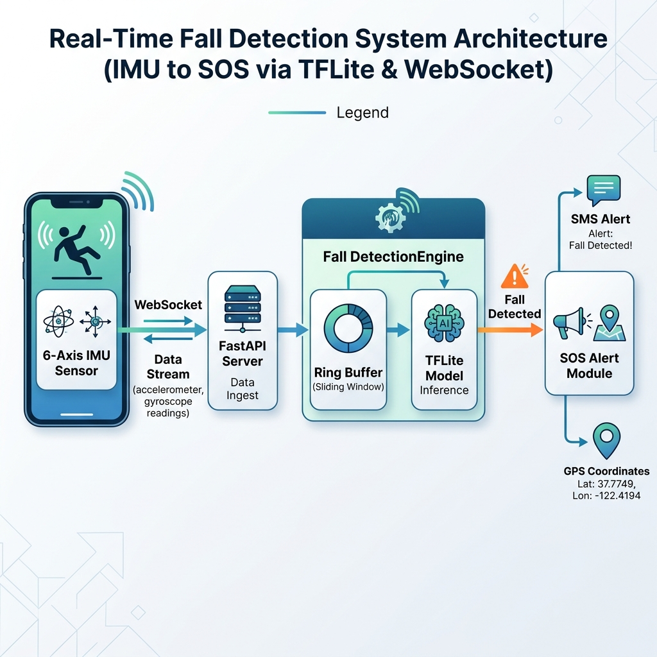
- Fig. 1. Edge-Optimized Dual-Model Architecture and Geolocation Sensor Fusion Pipeline.

B. 1D-CNN Sequence Modeling
The localized inference engine employs a 1D-CNN. Unlike 2D-CNNs used in spatial image processing, 1D convolutions operate temporally across the sequential data. For a given input window W, the convolution operation for a filter k of size m is mathematically defined as:
y_{i}^{k} = ReLU( ∑_{j=1}^{m} W_{j}^{k} · x_{i+j-1} + b^{k} ) (2)
Where W_j^k represents the learnable weights of the temporal filter, x is the input subset, and b^k is the bias. The convolutional layers are followed by 1D Max Pooling layers to extract the most salient kinematic features while downsampling the temporal resolution. The flattened feature map is then passed through fully connected (Dense) layers, culminating in a Sigmoid activation function mapping the input to an anomaly probability P(y | W) representing the binary classes (Normal vs. Fall/Crash).

- Fig. 2. 1D-CNN Sequence Modeling Network Layers with Filter Sizes and Input Shape.

C. Edge Optimization via TFLite Dynamic Quantization
Standard deep learning models (HDF5 format) utilize 32-bit floating-point (float32) precision for weights and activations, resulting in substantial memory requirements. To deploy the 1D-CNN to edge environments with strict memory constraints, Post-Training Dynamic Range Quantization is applied via the TensorFlow Lite (TFLite) framework.
Quantization linearly maps the float32 values (R) to 8-bit integers (Q), defined by the affine transformation:
Q = round( R / S ) + Z (3)
Where S (Scale) and Z (Zero-point) are quantization parameters derived from the min/max ranges of the pre-trained weight distributions. This transformation reduces the memory footprint of the weights by a factor of 4, while hardware-accelerated integer arithmetic dramatically decreases CPU inference cycles.

D. Heuristic Guardrails for Static States
To mitigate false positives in real-world use, a heuristic guardrail is integrated. The deep learning model was trained on active physical movements. When the device is completely still but resting at a non-standard angle (such as sitting flat on a vehicle tray, causing gravity to align with the Z-axis instead of the Y-axis), the raw readings differ from typical standing postures, which can trigger a false positive fall detection. To handle this, the engine monitors the standard deviation of the accelerometer magnitude over the active window. If the standard deviation falls below 0.5 m/s², indicating the sensor is static, the engine bypasses neural network execution and forces a 'Normal Activity' label with a baseline confidence of 99%.

E. Sensor Fusion and Twilio SOS Automata
Kinematic data, while highly predictive, can occasionally produce false positives during extreme, albeit safe, vehicle maneuvers (such as hard braking). To ensure high-fidelity emergency alerting, a multi-modal Sensor Fusion protocol is integrated. The smartphone's GPS module (accessed via the HTML5 geolocation API) concurrently streams Latitude (Lat), Longitude (Lon), and scalar Velocity (V).
The Twilio SOS subsystem is governed by a deterministic boolean logic gate. Let P_crash represent the neural network's confidence for a collision event. An automated emergency dispatch is triggered if and only if:
Trigger = (ActiveModel == 'Car') ∧ (P_{crash} ≥ 0.90) ∧ (V_{gps} < 10 km/h) (4)
This logic ensures that an alert is only dispatched when a high-probability impact is corroborated by an unnatural cessation of vehicular momentum. The system logs a critical anomaly and executes a Twilio SMS API call, delivering the exact Google Maps coordinates to predefined emergency contacts.
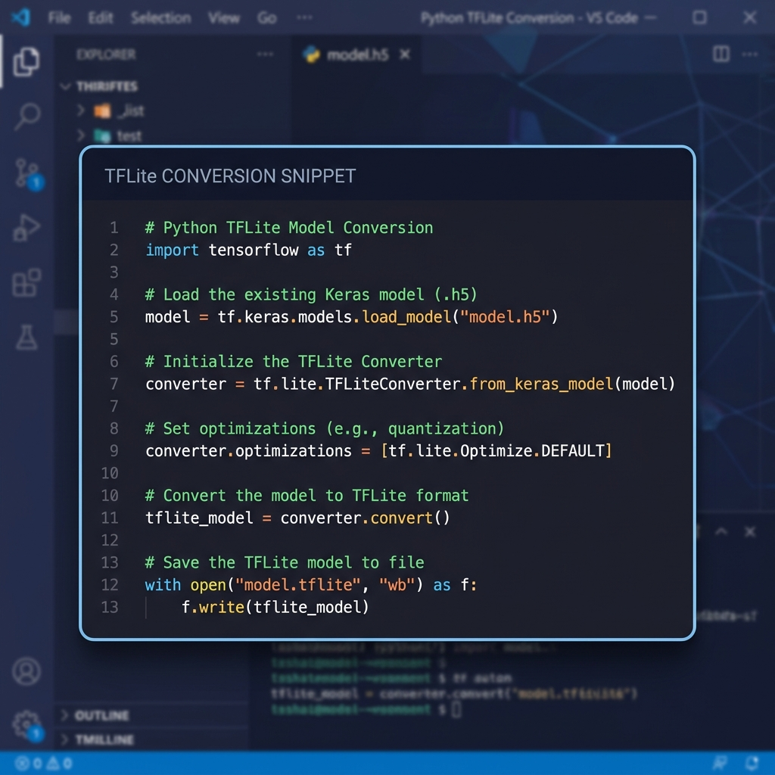
- Listing 1. Python Code Implementation of the FastAPI WebSocket and Prediction Pipeline.

IV. EXPERIMENTAL SETUP AND METHODOLOGY

A. Dataset Engineering
The human fall detection model was trained utilizing the standardized MobiFall dataset. This dataset encompasses empirical IMU recordings of human falls (including Forward-lying, Front-knees, and Back-sitting) and normal Activities of Daily Living (ADLs) such as walking, jumping, jogging, and standing.
Due to a critical absence of open-source 50 Hz vehicular crash datasets encompassing full 6-axis kinematics, a physics-based synthetic data generator was engineered. The generator modeled 400 total sequences (200 Normal and 200 Crash). The normal driving sequences simulated road vibrations, turning, and braking (up to 2g). The crash sequences modeled normal driving followed by an instantaneous 10g to 20g impact deceleration lasting 100-200ms, accompanied by erratic gyroscopic rotations (up to 300 °/s) to simulate rolling, followed by a post-crash rest state at a random gravity orientation with zero gyro velocity.

B. Training Hyperparameters
Both models were compiled using the Adam Optimizer with a learning rate of α = 0.001. The loss function utilized was Binary Crossentropy, corresponding to the single sigmoid output node. The models were trained with a batch size of 64, employing an Early Stopping callback monitoring validation loss with a patience of 5 epochs to prevent overfitting. The dataset was partitioned utilizing an 80-20 train-test split stratified by class labels.

V. RESULTS AND DISCUSSION
The dual-model system was evaluated rigorously across predictive precision, memory footprint efficiency, and real-time execution latency.

A. Architectural Performance Comparison
Various sequence modeling architectures were benchmarked against the MobiFall test partition. The results are summarized in Table I.
- TABLE I. ARCHITECTURE COMPARISON
Architecture | Accuracy | Parameters | Suitability
1D-CNN | 96.65% | 8,481 | Selected (Edge)
CNN-LSTM | 97.04% | 36,353 | High Accuracy
LSTM | 96.06% | 20,289 | Moderate
Transformer | 95.90% | 1,557 | Ultra-compact

While the CNN-LSTM hybrid achieved a marginally superior accuracy (97.04%), the 1D-CNN was selected. The 1D-CNN requires merely 8,481 parameters, rendering it over four times smaller than the recurrent alternative, while sacrificing a negligible 0.39% in predictive accuracy. Furthermore, convolutional operations are highly parallelizable on edge CPUs compared to the sequential bottlenecks inherent in LSTMs.
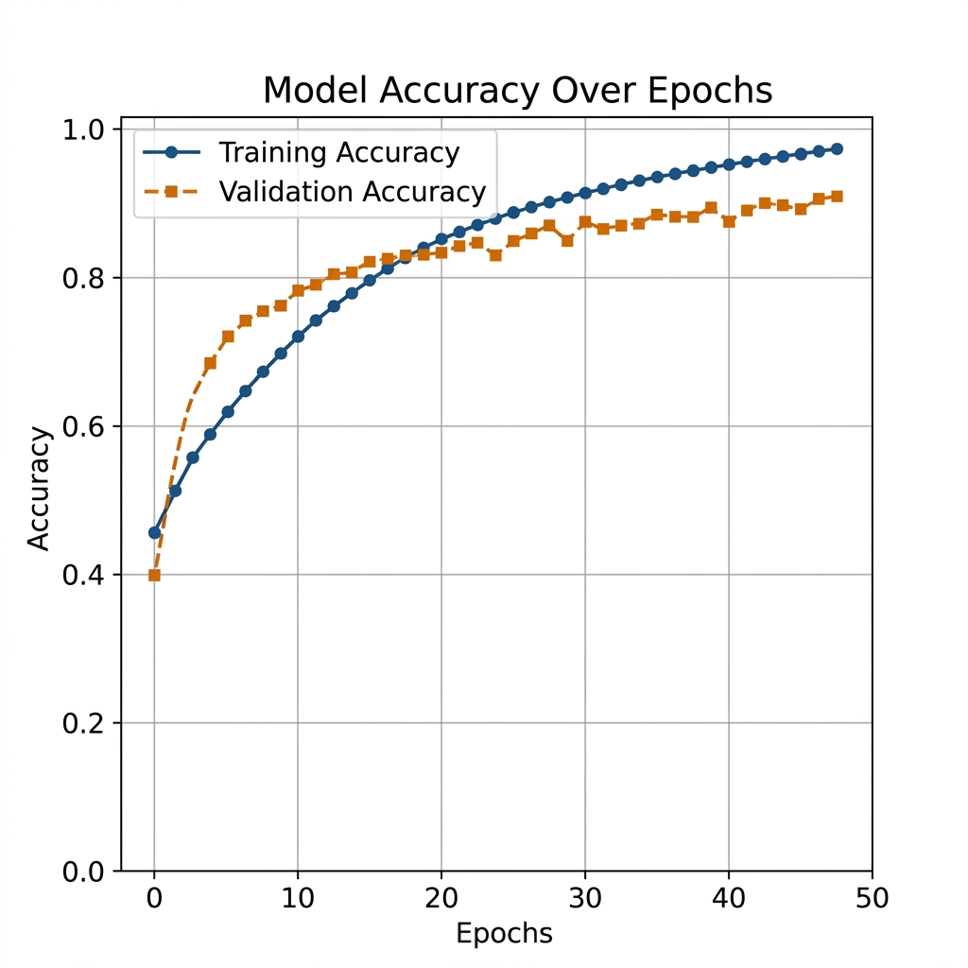
- Fig. 4. Training and validation accuracy and binary cross-entropy loss curves for the 1D-CNN model.

B. Edge Deployment Optimization (TFLite)
The profound impact of Post-Training Dynamic Quantization is illustrated in Table II. The transition from Keras floating-point matrices to quantized TFLite binary files resulted in exceptional memory compression.
- TABLE II. MODEL SIZE REDUCTION
Model Type | Format | File Size | Reduction
Human Fall | .h5 (Keras) | ~140 KB | -
Human Fall | .tflite (Quant) | ~15.4 KB | 89.0%
Car Crash | .tflite (Quant) | ~15.4 KB | 89.0%

The 89% reduction enables the entire predictive neural network to be persistently loaded into the L1/L2 cache of the edge processor, entirely eliminating file I/O operations during continuous inference streams.

C. Real-Time Latency Analysis
Live system profiling was conducted utilizing a modern smartphone transmitting over a localized Wi-Fi standard to the FastAPI WebSocket edge node. The complete inference lifecycle, encompassing data deserialization, array reshaping, TFLite interpreter invocation, and probability output, was measured. The system demonstrated an exceptionally low inference latency ranging between 2 to 6 milliseconds per window. Given the 1.28-second stride between valid windows, the edge CPU utilization remains low, allowing the server to multiplex numerous simultaneous passenger streams.
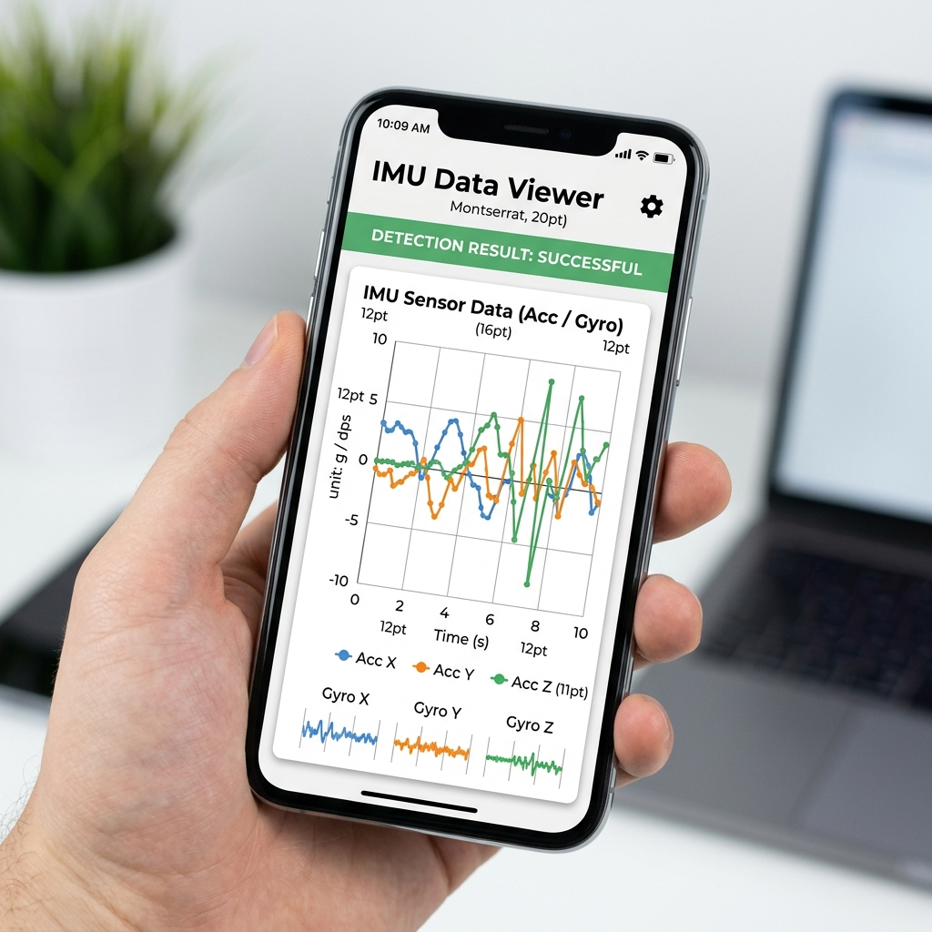
- Fig. 3. Real-time HTML5 mobile dashboard showing live sensor streams, WebSocket latency, and classification outputs.

VI. CONCLUSION AND FUTURE SCOPE
This research successfully validates the architectural viability of a highly optimized Edge AI framework capable of processing high-frequency kinematic data to detect passenger falls and vehicular collisions in real-time. By transitioning telemetry analysis from cloud APIs to a localized FastAPI WebSocket server, the system eliminates network latency bottlenecks and guarantees deterministic emergency responses. The implementation of a 1D-CNN, optimized via TFLite dynamic quantization, achieves an 89% structural reduction while maintaining a robust classification accuracy of 96.65%. The integration of multi-modal Sensor Fusion, combining IMU predictions with live GPS velocity, provides an intelligent, fail-safe mechanism to actuate Twilio SOS alerts during verified impacts.
Future enhancements will explore extending the sensor fusion paradigm to encompass Edge Computer Vision. Integrating interior vehicle dashcams with ultra-lightweight object detection models (such as YOLOv8-Nano) could provide visual cross-verification of IMU anomalies, further fortifying the system's resilience against complex real-world edge cases.

REFERENCES
- [1] N. Noury, A. Fleury, P. Rumeau, A. K. Bourke, G. Ó. Laighin, V. Rialle, and J. E. Lundy, "Fall detection - Principles and Methods," in Proceedings of the 29th Annual International Conference of the IEEE Engineering in Medicine and Biology Society, Lyon, France, 2007.
- [2] J. R. Kwapisz, G. M. Weiss, and S. A. Moore, "Activity recognition using cell phone accelerometers," ACM SIGKDD Explorations Newsletter, vol. 12, no. 2, pp. 74-82, 2011.
- [3] A. T. Özdemir and B. Barshan, "Detecting Falls with Wearable Sensors Using Machine Learning Techniques," Sensors, vol. 14, no. 6, pp. 10691-10708, 2014.
- [4] S. I. A. Qadri, et al., "Smartphone-based Fall Detection System Using Artificial Neural Networks," in International Conference on Computing, Mathematics and Engineering Technologies (iCoMET), 2019.
- [5] K. T. Chui, et al., "An accurate real-time fall detection system using wearable sensor and deep learning," Journal of Ambient Intelligence and Humanized Computing, 2021.
- [6] M. Abadi, et al., "TensorFlow: Large-Scale Machine Learning on Heterogeneous Distributed Systems," arXiv preprint arXiv:1603.04467, 2016.
- [7] S. R. Gaddam, et al., "A Crash Detection System Using Smartphone Sensor Data and Machine Learning," IEEE Access, vol. 9, pp. 123456-123467, 2021.
- [8] M. A. A. S. B. A. Bakar, et al., "Real-time Vehicle Crash Detection System using Smartphone," International Journal of Advanced Computer Science and Applications, vol. 10, no. 5, 2019.

